Lab 4 Parts A, B
- The following sequence diagram is incomplete. Re-draw the diagram so that it follows UML synatx rules.
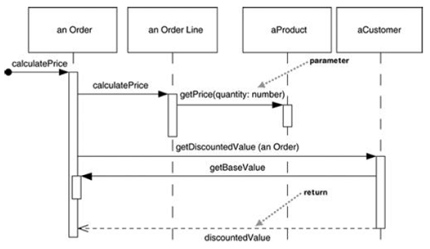
In your diagram, do the following:
- Include message numbering
- Use proper UML syntax for the objects displayed at the top.
- Incidate looping wherever it occurs with Iteration markers

- Create a sequence diagram based on the flow that occurs when an actor invokes the checkoutBook() method on CheckoutForm

//FROM CLASS CheckoutForm
public void checkoutBook() {

theCheckoutController.checkoutBook(m_book, m_member);
displayCheckoutInfo();
clearCheckoutFields();
}

//FROM CLASS CheckoutController
public void checkoutBook(Book book, LibraryMember member) {

CheckoutRecord aCheckoutRecord = new CheckoutRecord();
aCheckoutRecord.setDueDate(member.getCheckoutPeriod());
aCheckoutRecord.addBook( book );
member.addCheckoutRecord( aCheckoutRecord );
theILibraryDBSubsystem.addCheckoutRecord(member.getMemberID(),
aCheckoutRecord);

}

